Jenkins Task-04

1) Setup Jenkins CICD pipeline using freestyle job using Docker containers using below code.
Source Code: https://github.com/betawins/hiring-app.git
Stages:
- Git Clone
- SonarQube Integration
- Maven Compilation
- Nexus Artifactory
- Slack Notification
- Deploy On tomcat

Stage 1: Clone the given repository:
On Jenkins console, create new job and configure with git repo URL.
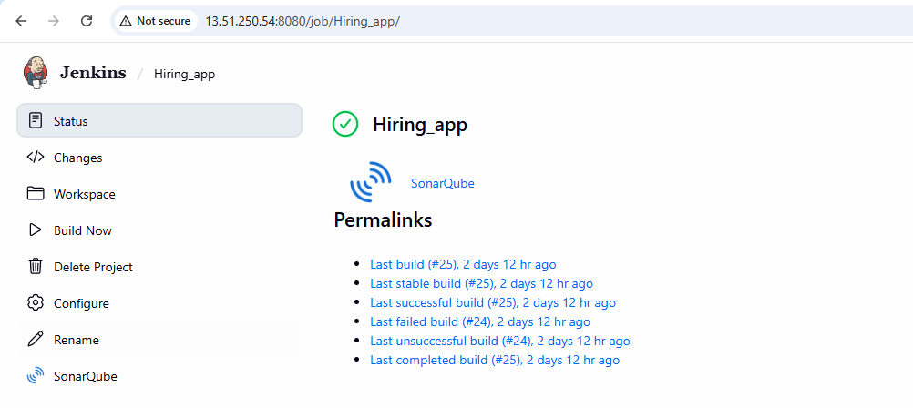
Then clicked build now and checked for the console output
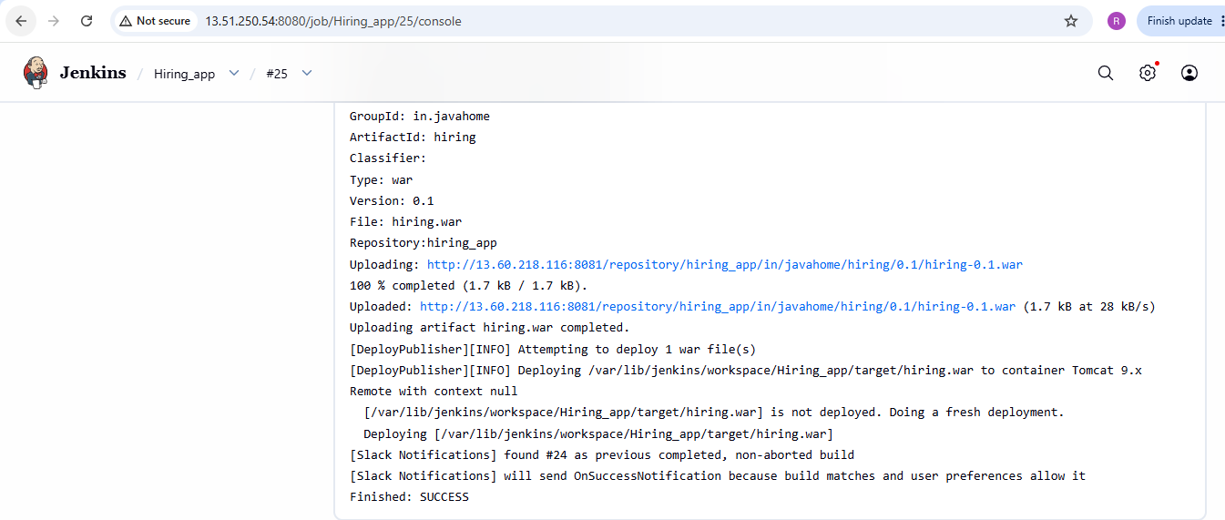
Also verified the clone on Jenkins server and see the code related to repository is cloned successfully
Stage 2: Sonarqube integration
1.Launch new instance named Sonarqube with capacity m7i-flex.large and volume 20 Gib.
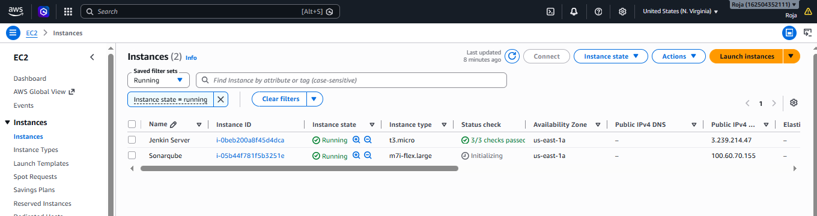
Start Sonarqube on Sonarqube server and make sure that it is running and then login to sonarqube GUI:
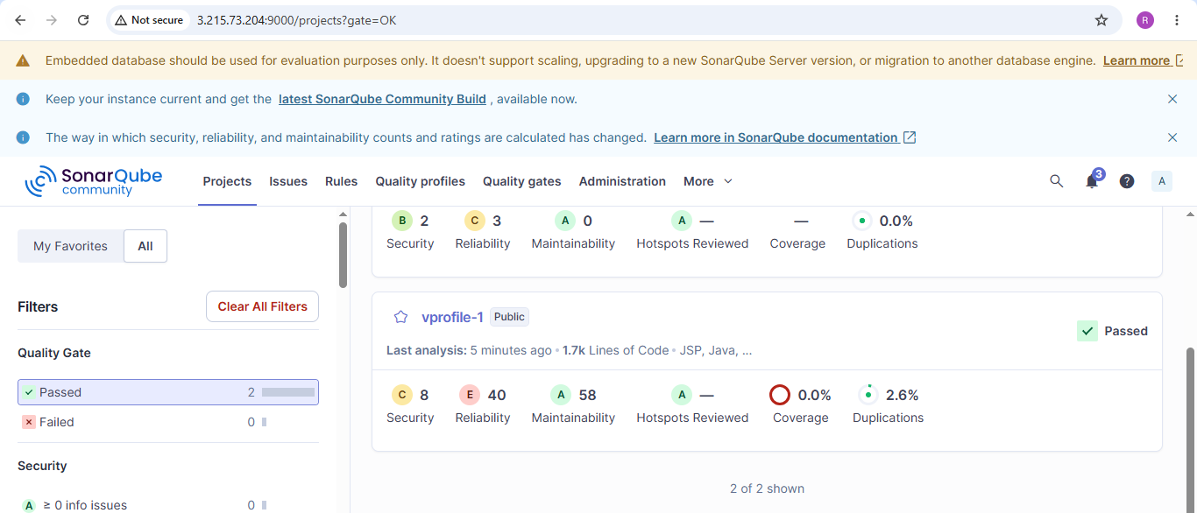

Stage 3: Maven Compilation
Install Maven and check maven version
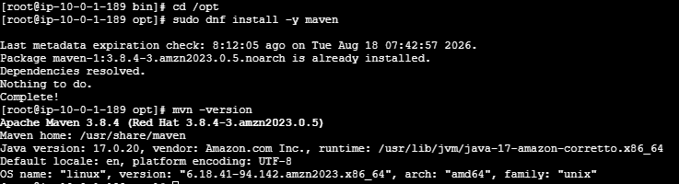
Verified the path of maven
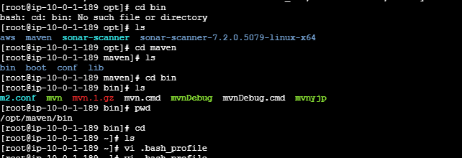
Storing maven path as global variable in bash_profile file:
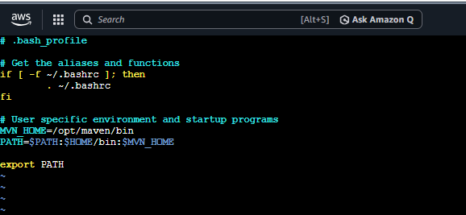

By adding maven path as global variable in bash_profile file we can access maven from any location i.e from home location also and we need not give entire path each and every time we need it.
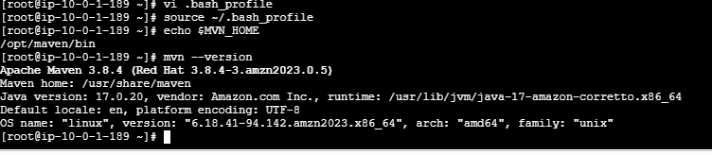
Now go to Manage Jenkins → Tools→ Maven Installations and add maven path. Click on save.

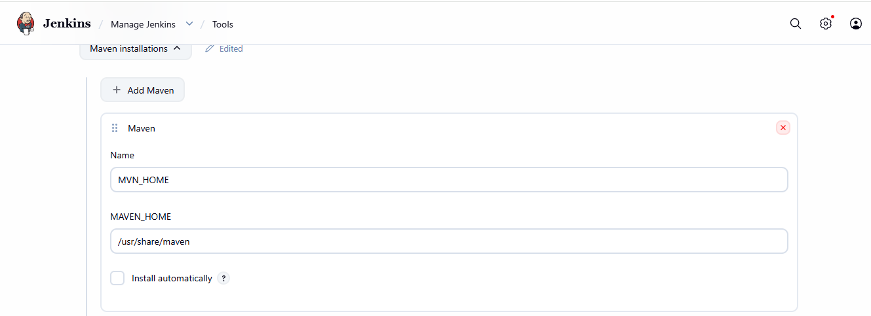
Go to Hiring _app→ Configure→ Add Build steps
Enter Maven version and goal.
Click on save.
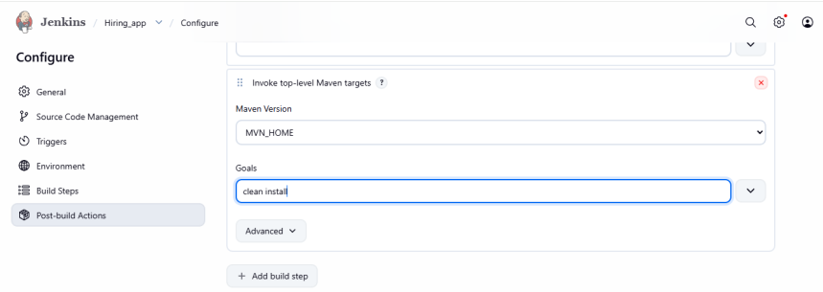

After configuration click on build now. Job is successfully executed.
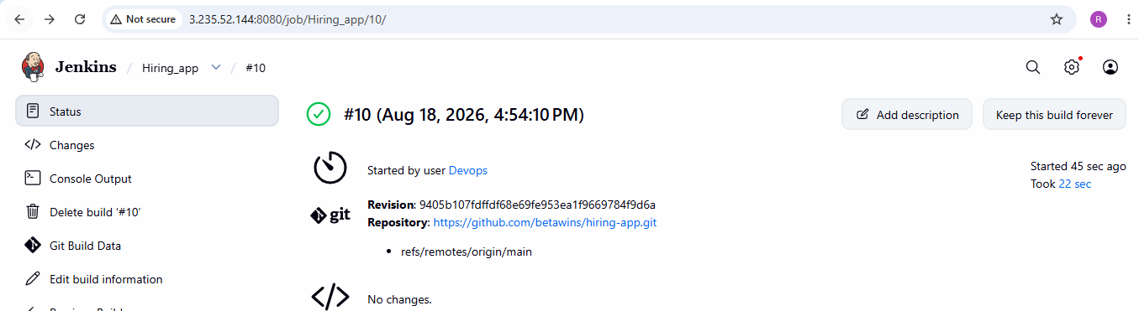

Stage 4: Nexus Artifactory
Installed java
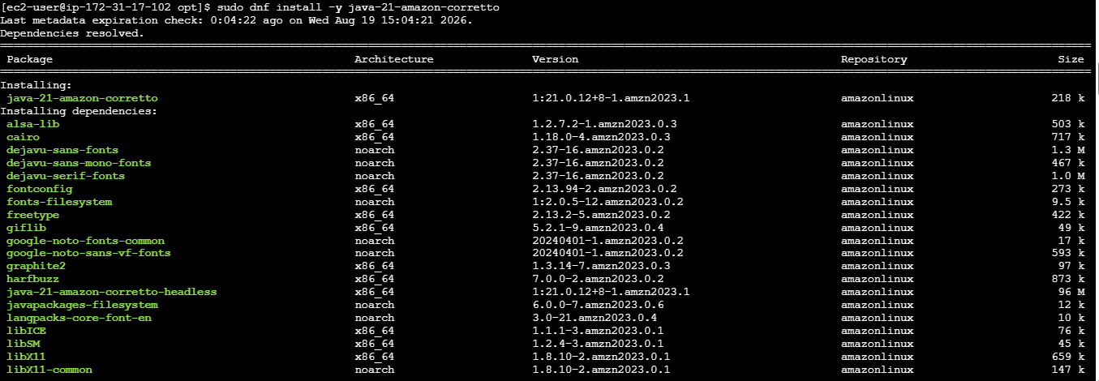
Extracted zip file

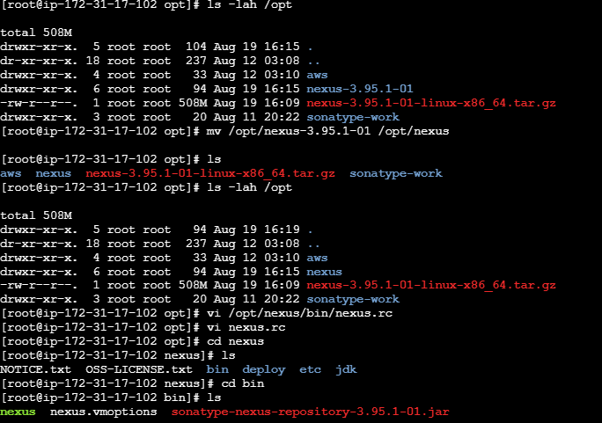

Open /opt/nexus/bin/nexus.rc file, uncomment run_as_user parameter and set it as following.

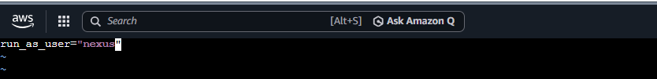

Started Nexus and checked the port number to see if its listening, port was not listening and nexus status running is also not shown

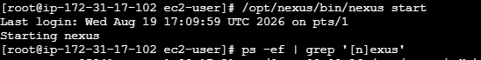
Checked free –m
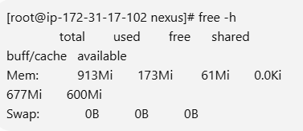
Identified the problem to be Nexus is configured to use about 2.7 GB of Java heap. If this EC2 instance has insufficient RAM, Nexus could be killed during startup.

For a small EC2 instance, reduce Nexus heap
cat /opt/nexus/bin/nexus.vmoptions
sed -i 's/-Xms2703m/-Xms512m/' /opt/nexus/bin/nexus.vmoptions
sed -i 's/-Xmx2703m/-Xmx512m/' /opt/nexus/bin/nexus.vmoptions
cat /opt/nexus/bin/nexus.vmoptions we see Xms512m

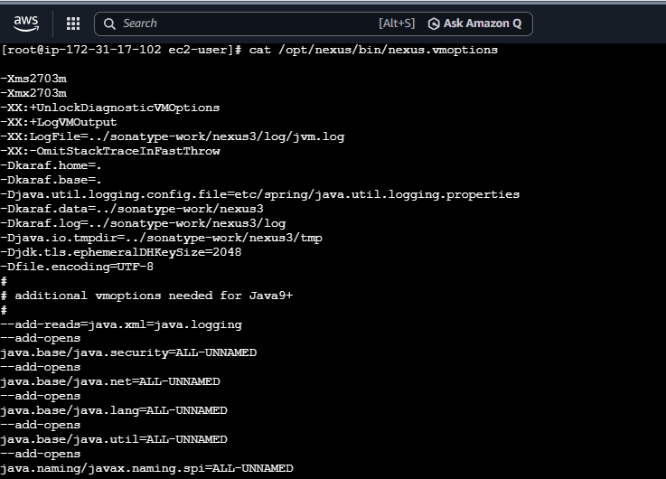
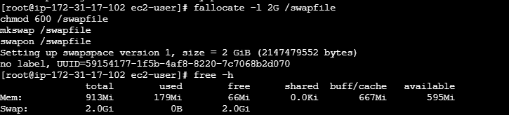

Checked the status of Nexus:
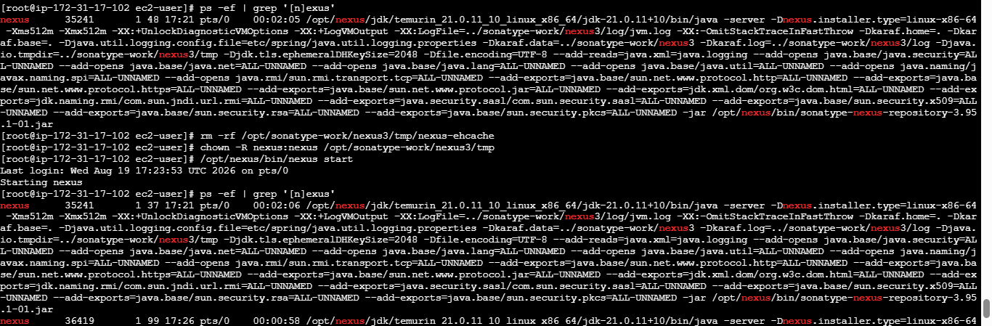

Checked if port is listening:

Now copy the public ip of Nexus and open in browser to get nexus GUI
After logging in with default password it asks to change the password so set a new password.
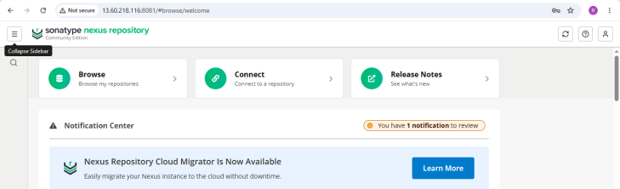

Integrate Nexus with Jenkins:
To integrate Nexus with Jenkins download plugin Nexus Artifact Uploader in Jenkins
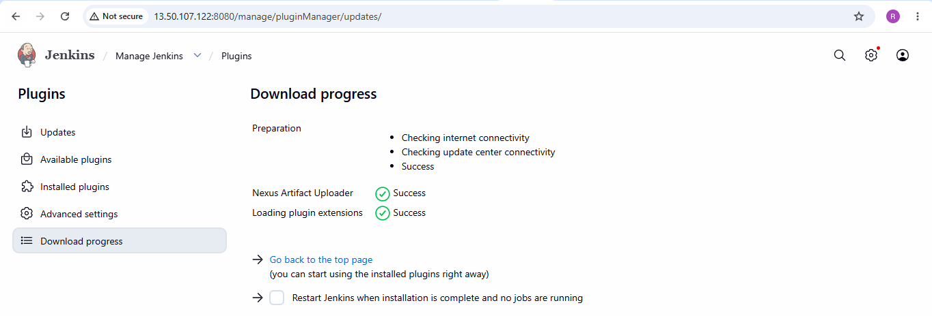
Go to Jenkins → Hiring app → configurations
Configure Nexus artifactory uploader. Before that create a repository in Nexus Artifactory GUI
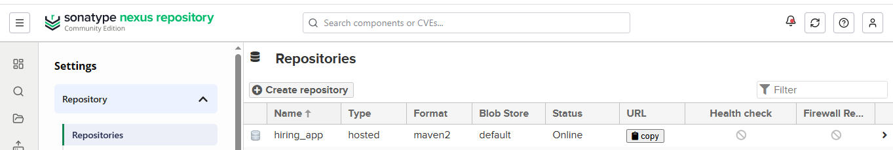

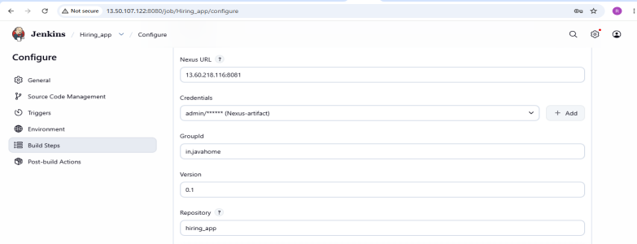

- Successfully executed job by clicking on build now:
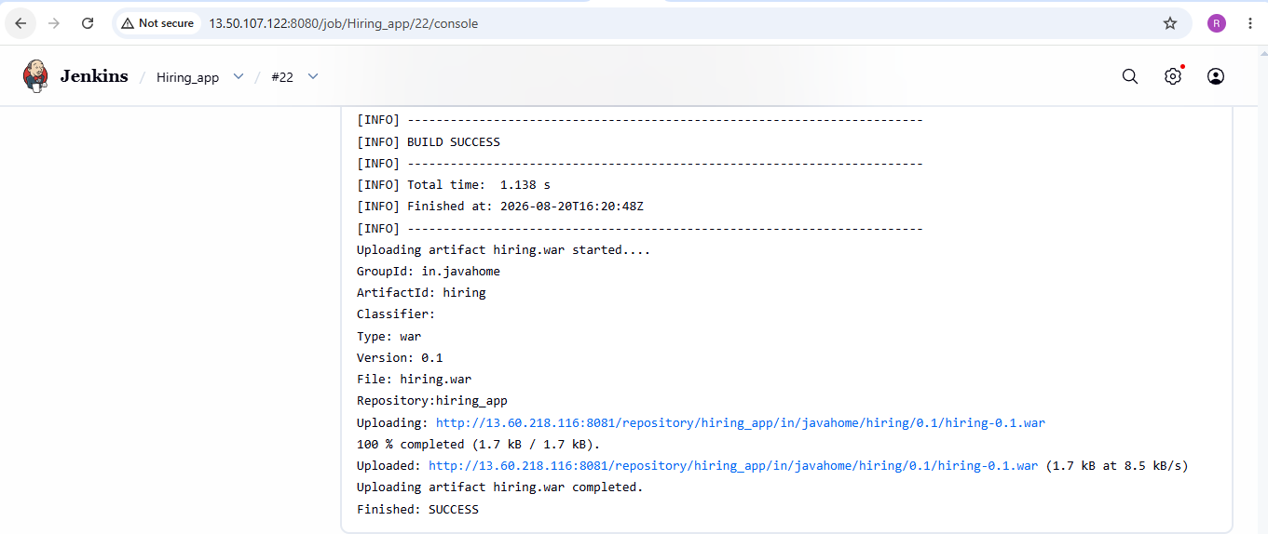
Stage 5: Configured slack notification
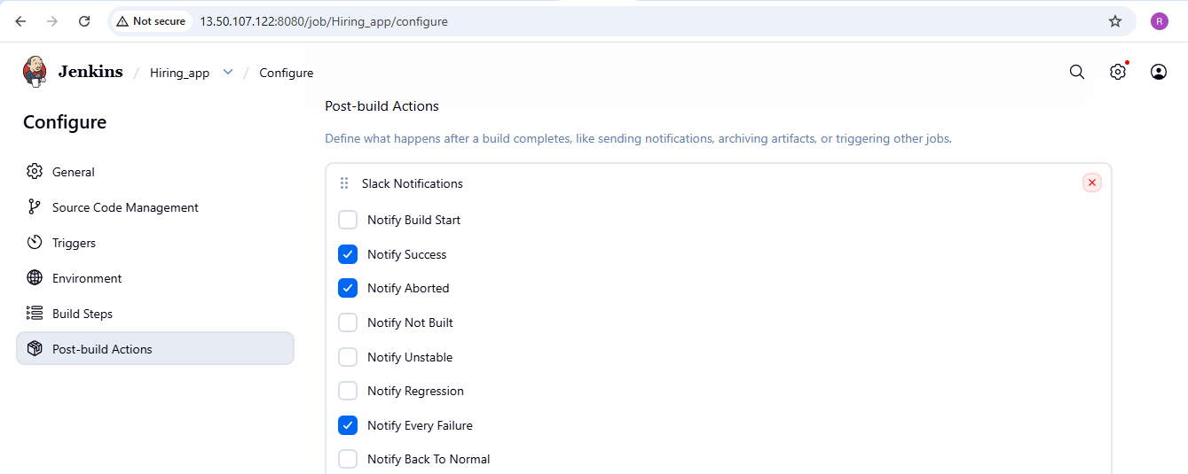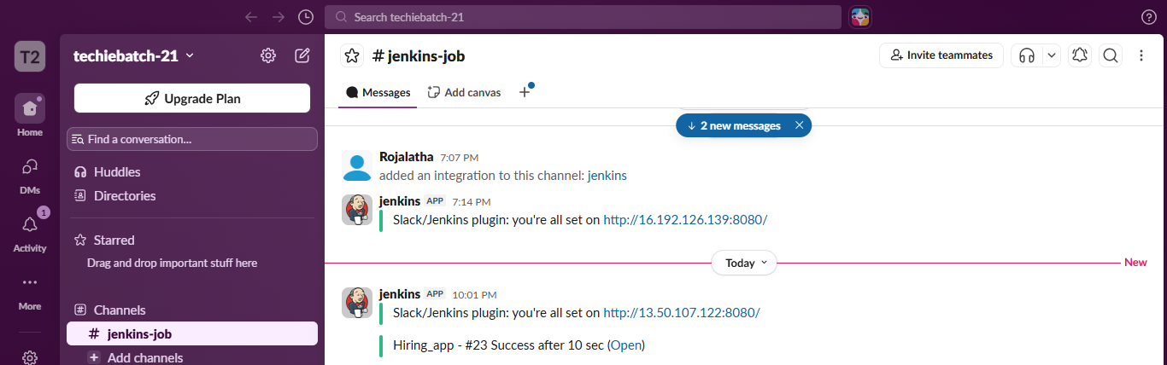
Stage 6: Deploy On tomcat
Go to Manage Jenkins → Plugins
Install Deploy to container
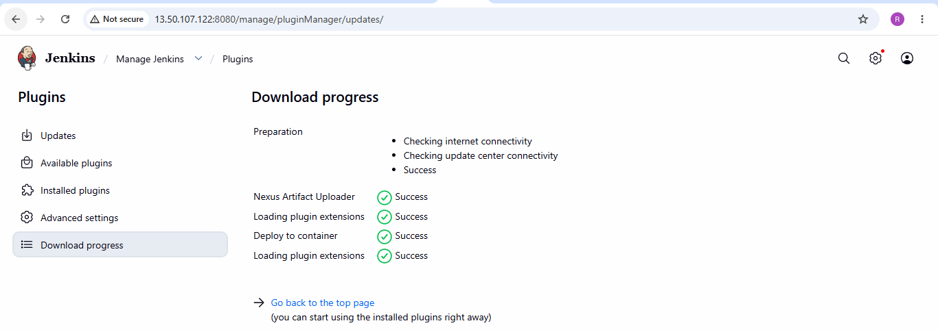
Launch an instance for tomcat deployment:
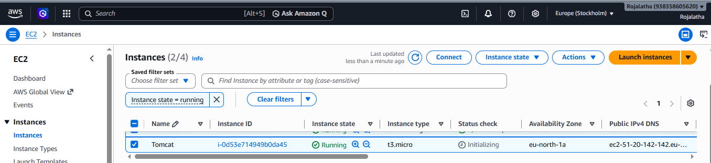
Connect to tomcat instance and install java and tomcat
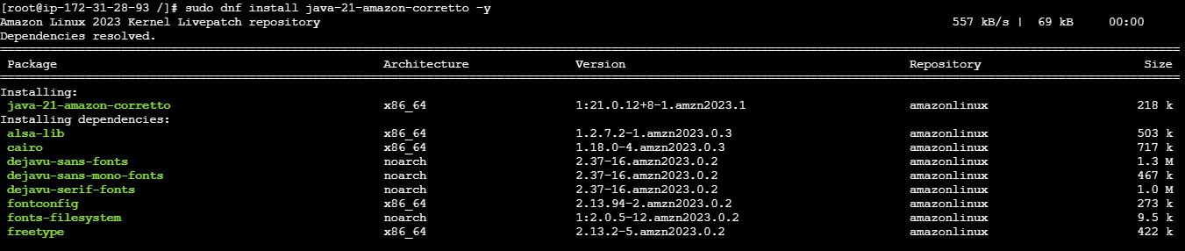

Then installed Tomcat zip file and unzipped the file
Renamed file as Tomcat and verified using ls
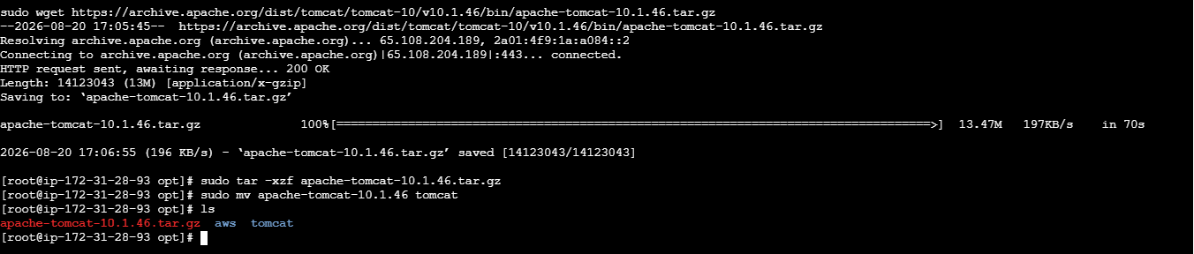
Now go to tomcat directory and start tomcat
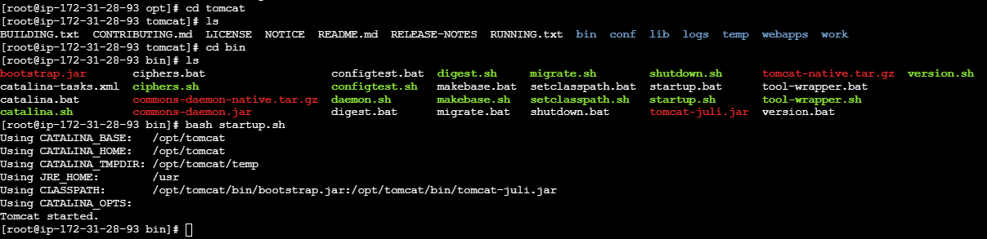
Using public ip and port number was able to open tomcat in browser
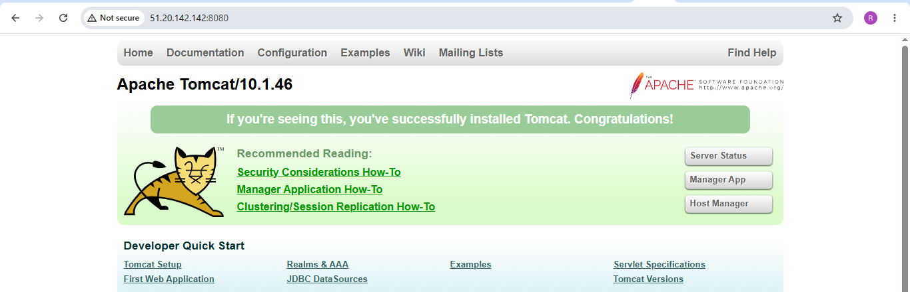
find / -name context.xml above command gives 3 context.xml files. comment (<!-- & -->) Value ClassName field on files which are under webapp directory. After that restart tomcat services to effect these changes
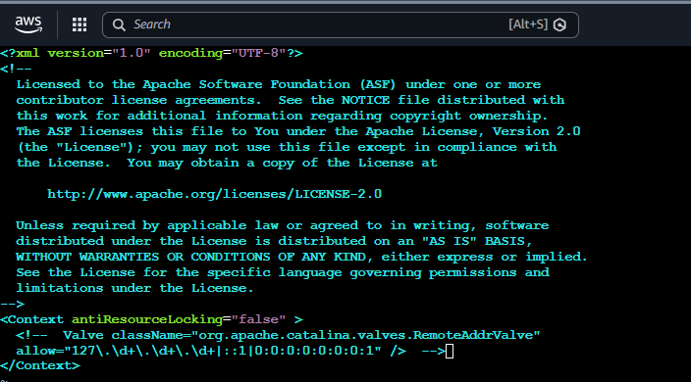

Similarly comment other 3 files
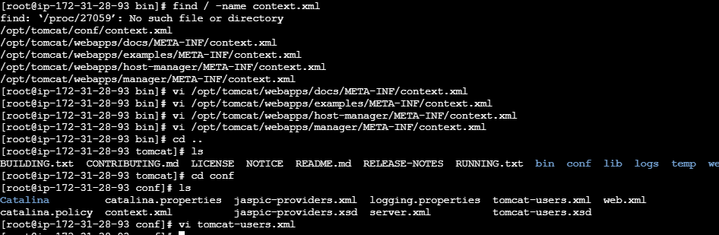
Go to tomcat-users.xml file and add users and role
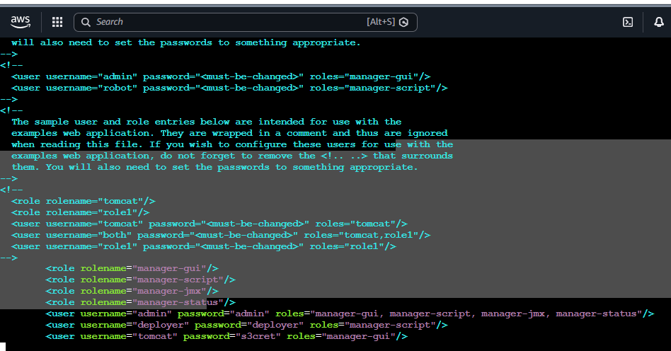

Shutdown and startup the tomcat
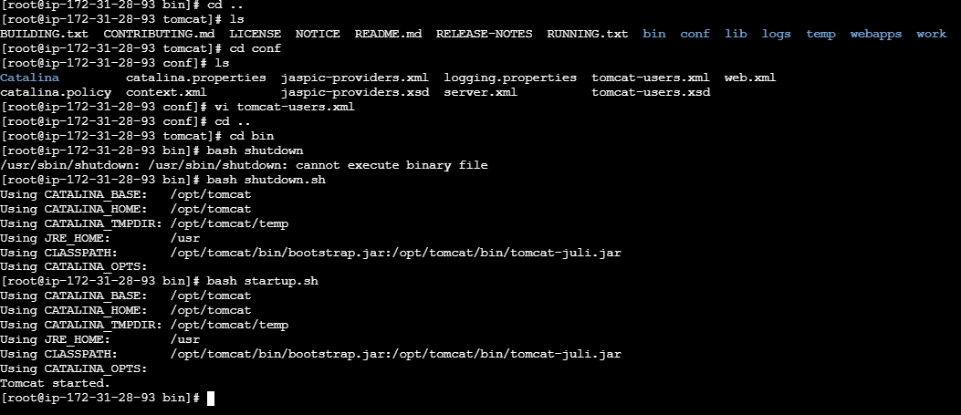

Go to Tomcat webpage and click on server status it asks for username and password
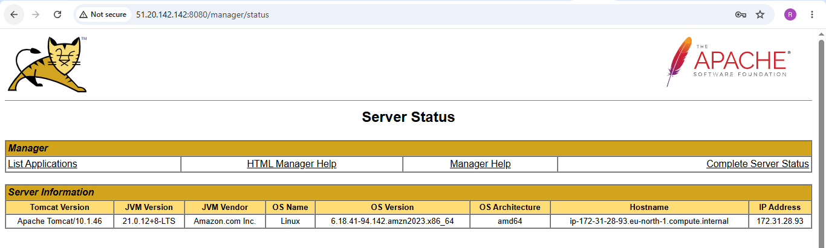
Go back to Jenkins GUI select job and configurations and configure deployment configurations
and click on build now. Job is successfully executed
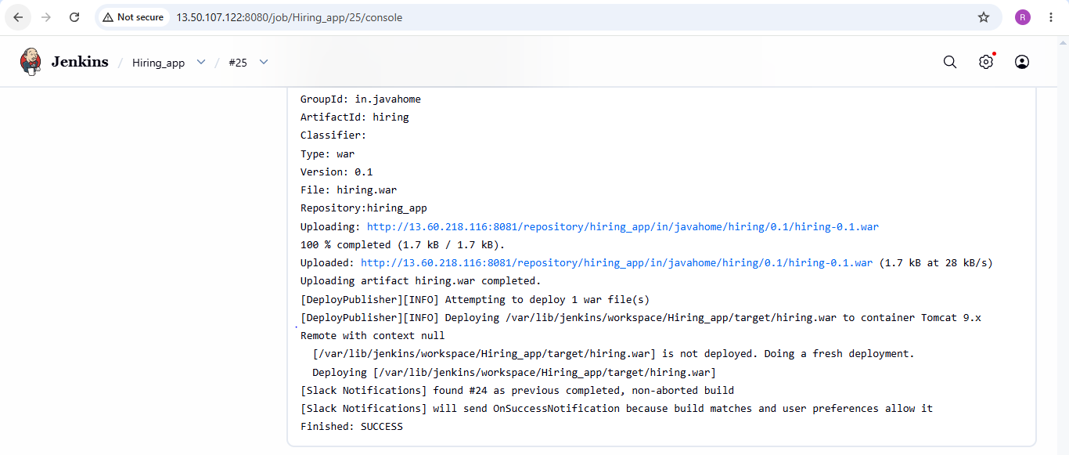

Also notification is sent to slack
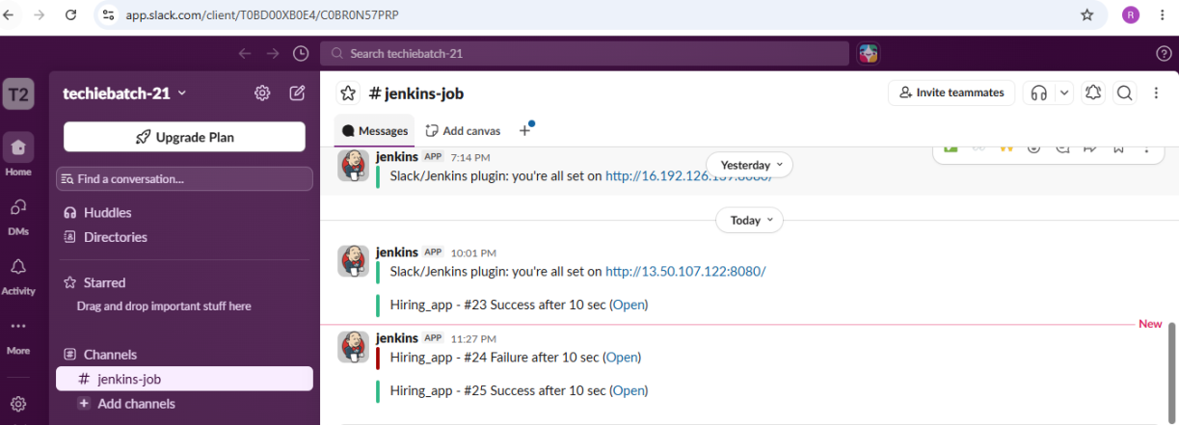

Deployed and access application:
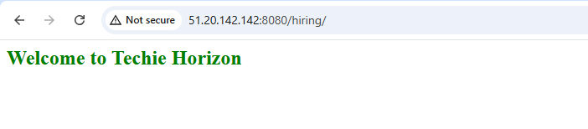
2) Setup a Jenkins CICD pipeline using Declarative pipeline using feature-1.1 branch.
Source Code: https://github.com/betawins/sabear_simplecutomerapp/tree/feature-1.1
stages:
- Git Clone
- SonarQube Integration
- Maven Compilation
- Nexus Artifactory
- Slack Notification
- Deploy On tomcat

Stage-1 Git clone
Create a new job with pipeline

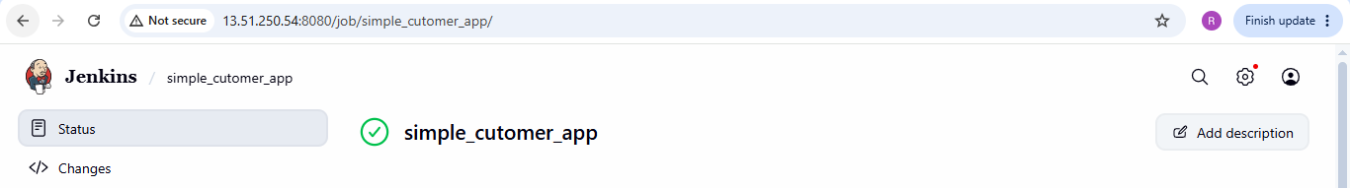

Verified clone on Jenkins server
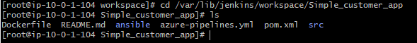

Then write a script in Jenkins under pipeline script:
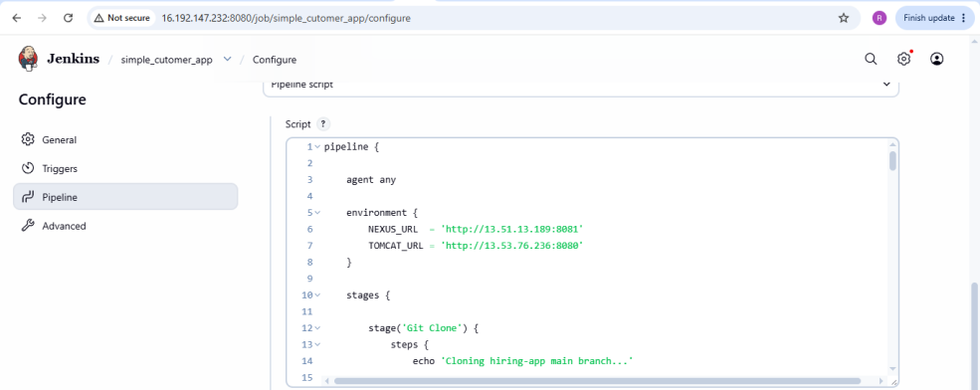
Build job and successfully executed the job
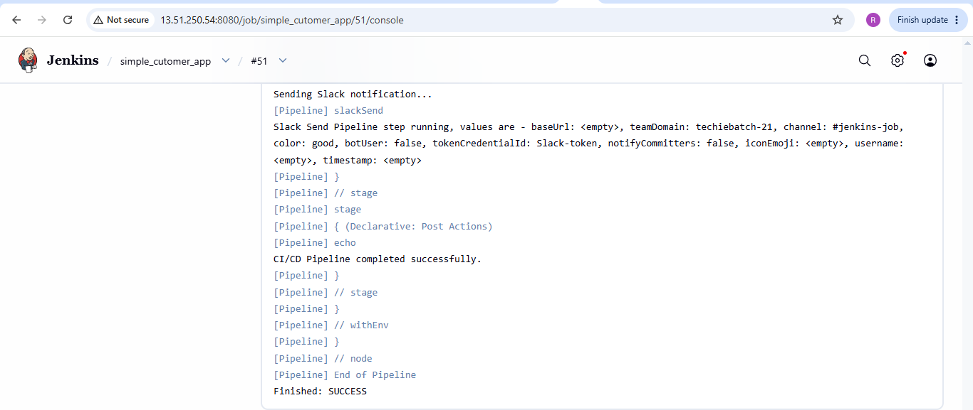

Stage 2: Sonarqube integration
Project is successfully pushed to sonarqube server:
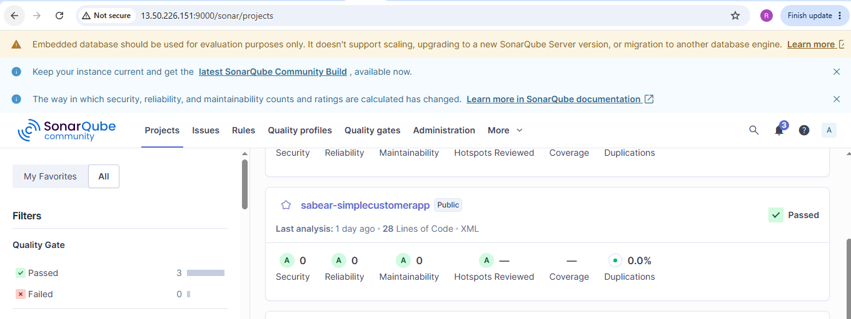

Stage 3: Maven compilation:
Enter the directory where project is present and verify the compile
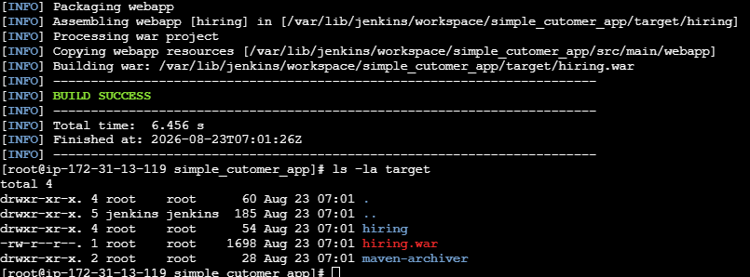

Stage 4: Created a new repo for simple customer app

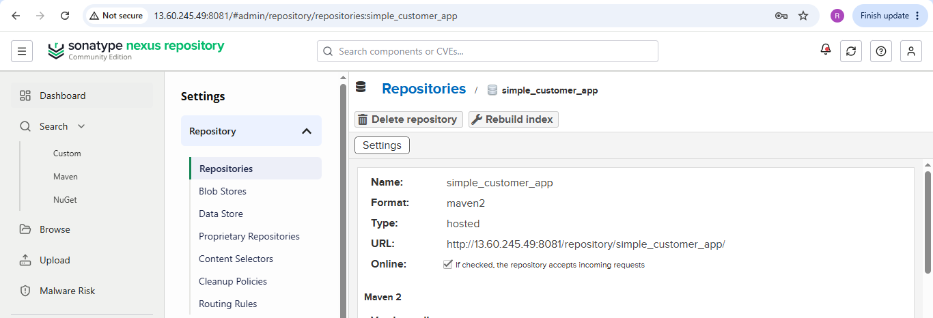

Stage 5: Slack notification
Successfully sent notification to slack after the job is build.
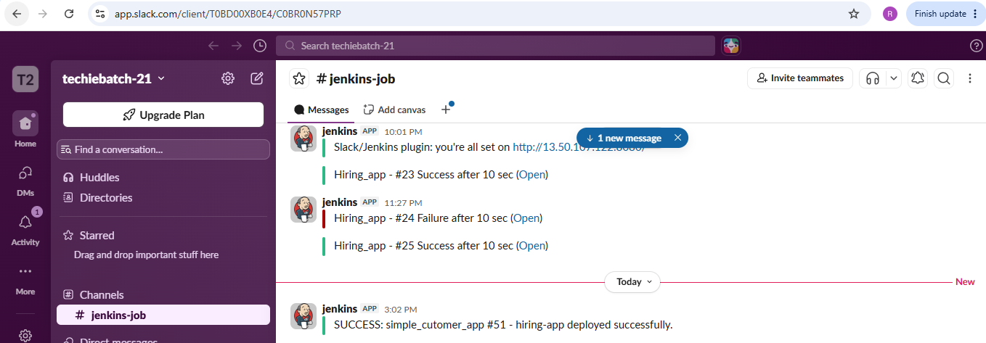
Stage 6: Deploy on Tomcat
Go to Tomcat webpage and click on server status it asks for username and password
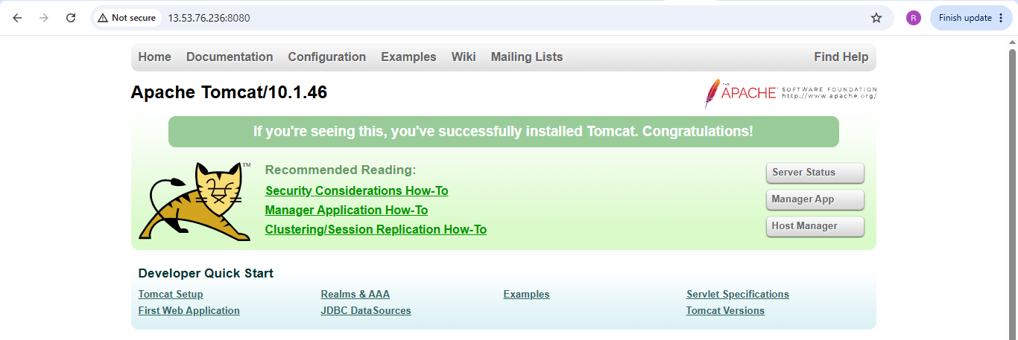
Deployed and accessed the webpage:
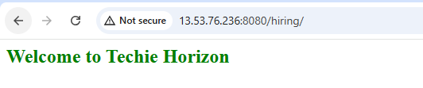

3) Setup a Jenkins CICD pipeline using Scripted pipeline using feature-1.1 branch.
Source Code: https://github.com/betawins/sabear_simplecutomerapp/tree/feature-1.1
stages:
- Git Clone
- SonarQube Integration
- Maven Compilation
- Nexus Artifactory
- Slack Notification
- Deploy On tomcat

Stage 1: Git clone:
Create a new job with Scripted pipeline
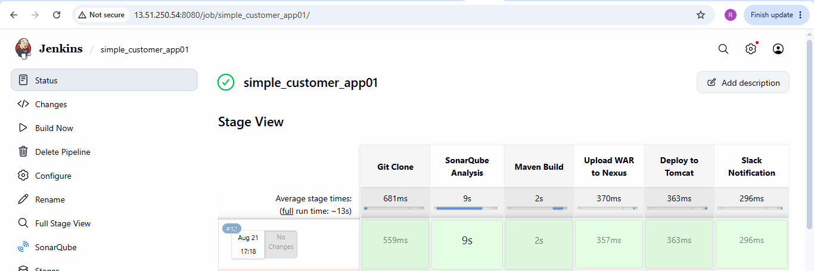

Then write a script in Jenkins under pipeline script:

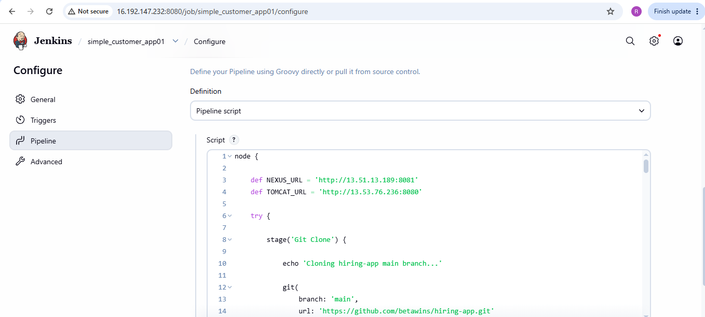

Verified clone on Jenkins server

Stage 2: Sonarqube integration
Pushed the project changes to sonarqube
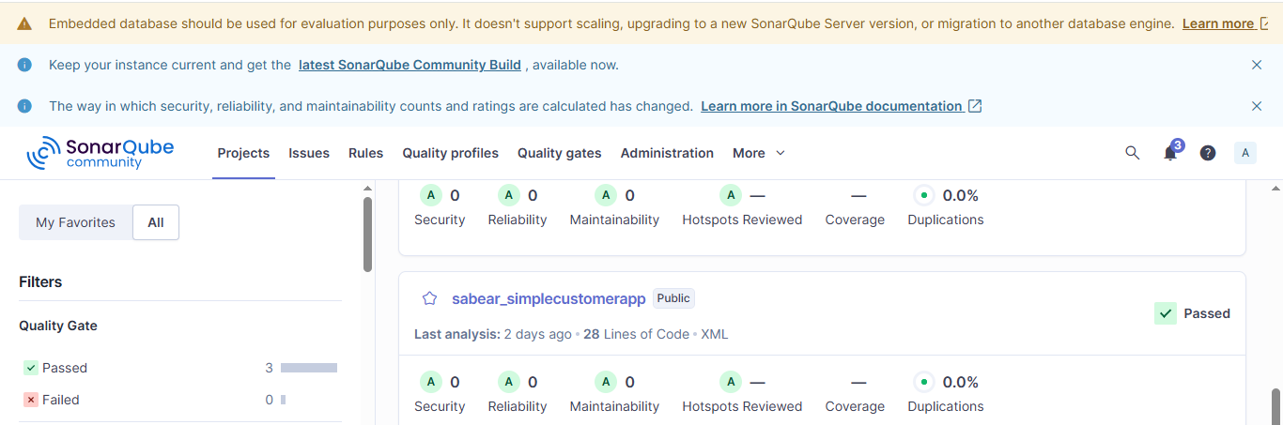

Stage 3: Maven compilation:
Enter the directory where project is present and verify the compile

Stage 4: Created a new repo for simple customer app

Stage 4 : Nexus Artifactory

Stage 5: Slack notification
Successfully sent notification to slack after the job is build.
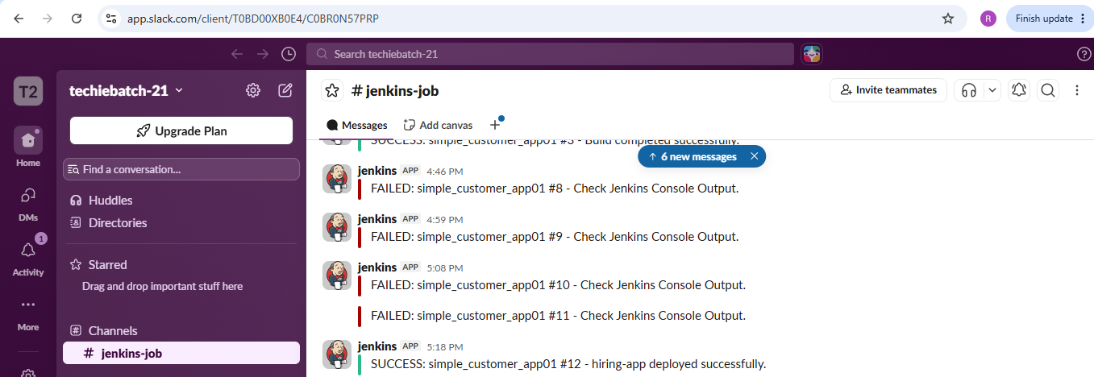

Stage 6: Deploy on Tomcat
Go to Tomcat webpage and click on server status it asks for username and password
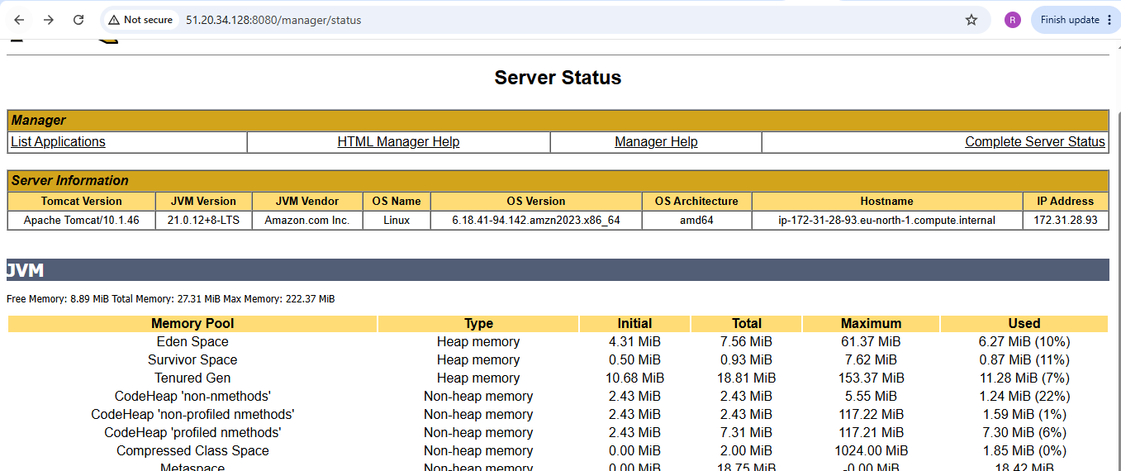

4) Write sample skeleton of pipelines.
Sample skeleton of declarative pipeline:
pipeline
{
agent any // Defines where the pipeline runs (any available agent)

// Optional: environment variables
environment {
VAR_NAME = "value"
}

// Optional: input parameters
parameters {
string(name: 'VERSION', defaultValue: '1.0', description: 'App version')
}

// Main workflow
stages {
stage('Build') {
steps {
echo 'Building project...'
// Example build command
sh 'mvn clean install'
}
}

stage('Test') {
steps {
echo 'Running tests...'
// Example test command
sh 'mvn test'
}
}

stage('Deploy') {
steps {
echo "Deploying version ${params.VERSION}..."
// Example deploy command
sh './deploy.sh'
}
}
}

// Optional: post actions (always, success, failure)
post {
always {
echo 'Pipeline finished.'
}
success {
echo 'Pipeline succeeded!'
}
failure {
echo 'Pipeline failed!'
}
}
}

Sample skeleton of scripted pipeline:

Node
{
// Allocate a Jenkins agent (node) to run the pipeline

// Optional: define environment variables
env.MY_VAR = "value"

stage('Build') {
// Steps inside the Build stage
echo "Building project..."
sh 'mvn clean install'
}

stage('Test') {
// Steps inside the Test stage
echo "Running tests..."
sh 'mvn test'
}

stage('Deploy') {
// Steps inside the Deploy stage
echo "Deploying application..."
sh './deploy.sh'
}

// Optional: add conditional logic
if (env.BRANCH_NAME == 'main') {
stage('Extra Checks') {
echo "Running extra checks on main branch..."
sh './extraChecks.sh'
}
}
}
5) Create a parameterized job in Jenkins.
Source Code: https://github.com/betawins/spring3-mvc-maven-xml-hello-world-1.git

Stage 1: Git clone
Created a parameterized job using pipeline
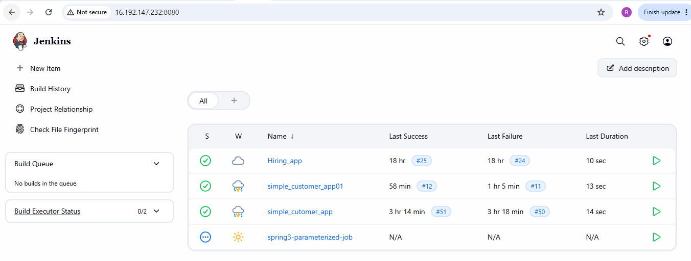
Successfully executed the job
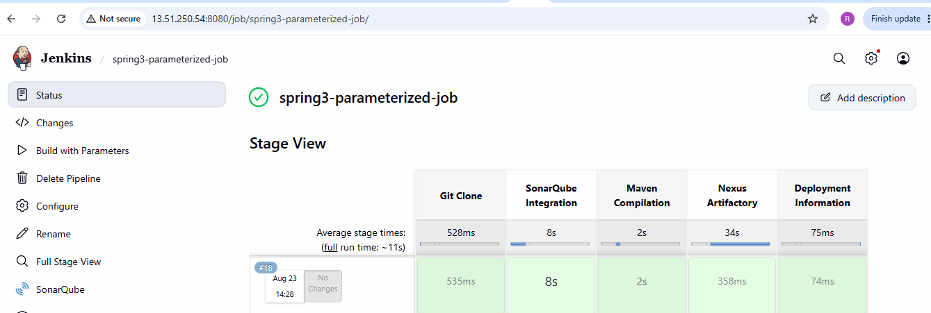
Verified the clone on Jenkins server:

Stage 2: Sonarqube integration:
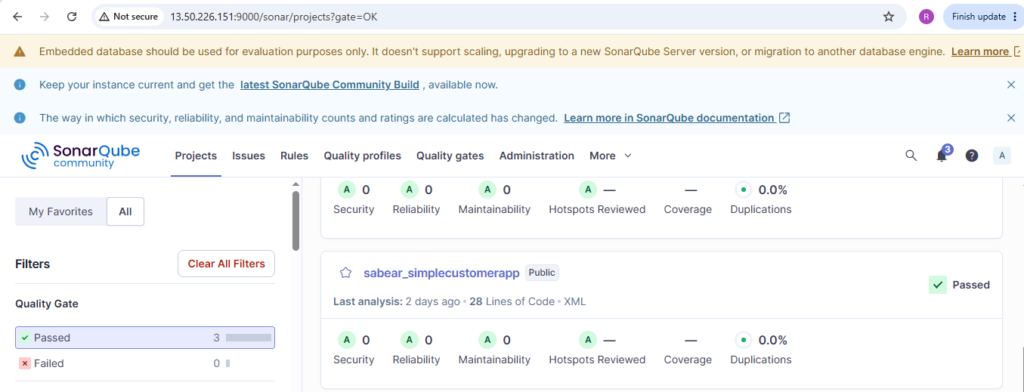

Stage 3: Maven compilation:
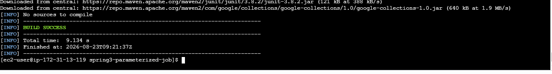
Stage 4: Nexus Artifactory:
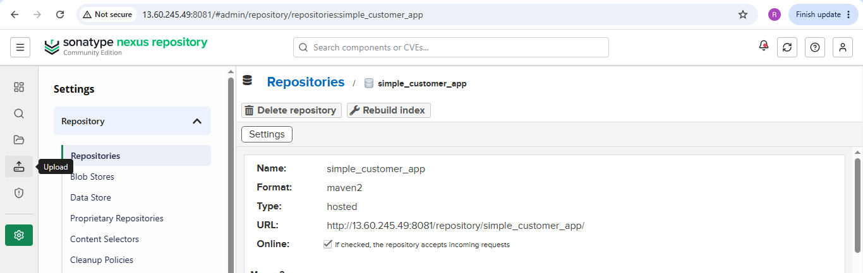

Stage 5: Slack Notification:
Successfully sent notification to slack after the job is build.

Stage 6: Deploy on Tomcat
Go to Tomcat webpage and click on server status it asks for username and password

6) Setup one slave machine for Jenkins.
Step 1: Create an EC2 instance

Create an additional Amazon Linux EC2 instance.
Jenkins-Agent-1
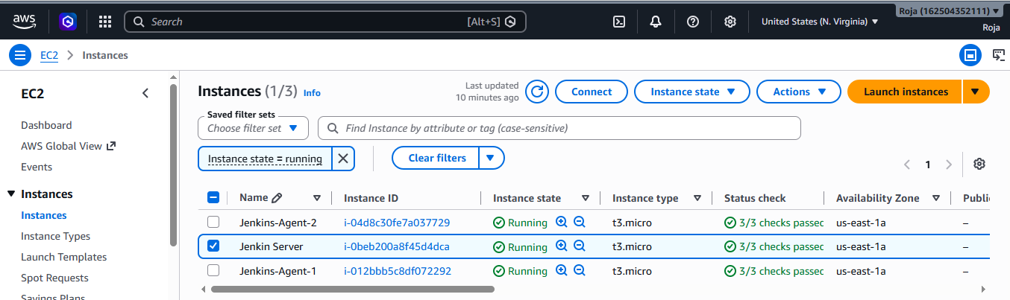

Step 2: Install Java on Agent 1 and check java version
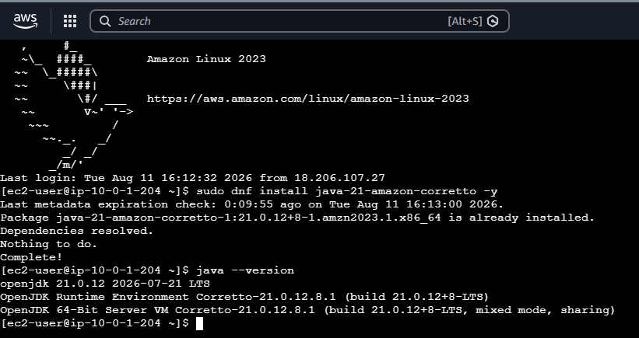

Step 3: Allow Jenkins Master to SSH to the Agents
On the Agent 1 Security Group, add an inbound rule:
Type: SSH
Port: 22
Source: Jenkins Master Security Group
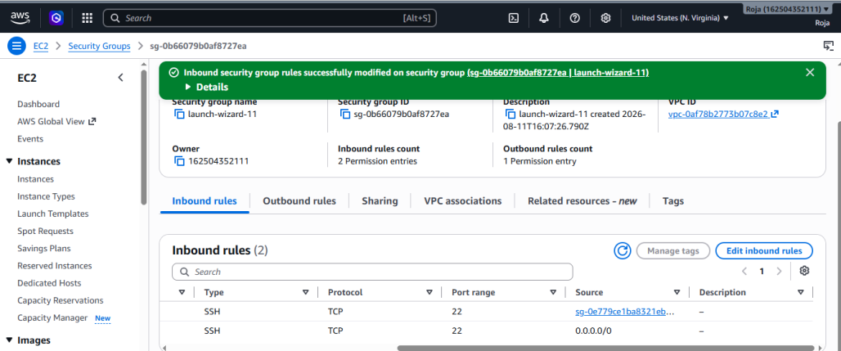

Step 4: Get Agent Private IP address
Go to: AWS Console → EC2 → Instances
Copy the Private IPv4 address of agent.
Agent 1 → 10.0.1.204
You will use this IP in Jenkins.
Step 5: Go to Jenkins Nodes
Open Jenkins: http://YOUR-JENKINS-IP:8081
Then:
Manage Jenkins
↓
Nodes

Click: New Node
Create Agent 1
Enter: Node name: agent-1
Select: Permanent Agent
Click: Create
Now configure:

Remote root directory
/home/ec2-user/jenkins

Labels: agent1

Usage : Select:
Only build jobs with label expressions matching this node

Launch method
Select: Launch agents via SSH
For Host, enter Agent 1's private IP: 10.0.1.204

Step 6: Test SSH from Jenkins Master
This step is very important.
SSH into your actual Jenkins master.
Find Agent 1's private IP in AWS:
Then from the Jenkins master run: ssh ec2-user@AGENT-1-PRIVATE-IP
If it asks: Are you sure you want to continue connecting?
Type: yes
You should get into Agent 1.
On Jenkins Agent-1:
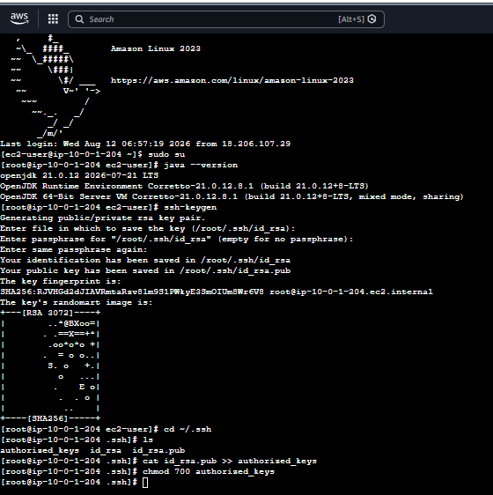

On master :
Create a directory
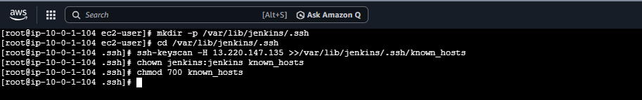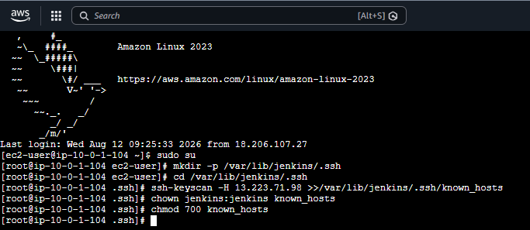
On Jenkins console:
Created Nodes for Agent-1
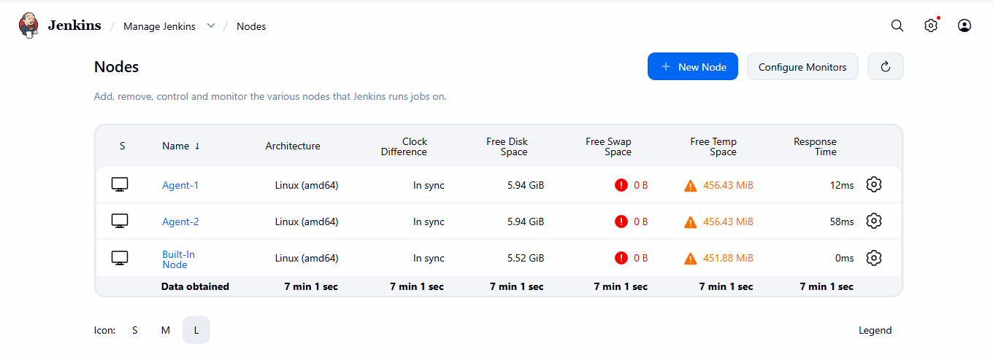
Created a job and build it successfully
